

FortnaPlus Control
Scanner Statistics
and the
History Module
Document Revision: 2.0
Date: 19-Aug-2022

Revision | Date | Author | Revision Summary
1.0 | 29-May-2018 | B C Conklin | New document
2.0 | 19-Aug-2022 | T R Kremser | Complete re-write and consolidation of related documents

Table of Contents
Glossary of Terms 5
1. History Gathering and Scanner Statistics 6
2. Understanding the System Configuration 6
2.1. Single Scanner (or Scale) 7
2.2. Tandem Scanners, Separate Interfaces 7
2.3. Multiple Scanners, Shared Interface 7
2.4. Print Apply Verification Scanners 7
3. Gathering the Data 7
4. History Configuration Wizard 8
4.1. Running the Configuration Wizard 9
4.2. Check the HistConfig Table 10
5. Launching the Display Program 10
6. The Display Program 11
6.1. Rates Data Tab 11
6.2. Lanes Data Tab 12
6.3. Sorters Data Tab 13
6.4. Scanners Data Tab 14
6.5. Display Program: Edit Configuration 15
6.5.1. Functions 17
6.6. Display Program Command Line Options 19
6.7. Display Program: File Menu 19
7. Table HistBoss 20
8. Table HistConfig 21
9. Table HistData 23
10. Table DbHistConfig 24
11. Table DbHistData 26
12. Data Collection Details 27
13. The Stats Archive Feature 29
14. The Old Way 31
15. The Trend Module 33
15.1. Trend Config and Calculation Screen 34
15.2. Trend Shared Memory Configuration Screen 36
15.3. Graph Trend Program Command Line Options 38

Confidential/Proprietary Statement
This document contains trade secrets and information that is considered confidential and proprietary to Fortna, Inc. It may not be duplicated, used, or disclosed outside the original recipient organization, and it may not be duplicated, in whole or in part, for any purpose other than to evaluate this document. Fortna Material Handling reserves the right to modify this document as necessary to reflect any terms and conditions negotiated and included as part of a subsequent contract or purchase order.

Glossary of Terms
AC – Automation Controller
FPC – FortnaPlus Control
UPS – Uninterruptible Power Supply

History Gathering and Scanner Statistics
The History Module, often referred to as Scanner Statistics, uses a set of tools within FPC and an external program (Display) in conjunction with the MySQL database to record, display and manage data on the health and performance of critical items in a conveyor system.
In addition to scanner performance data, sorter and/or transfer performance data such as error counts, lane divert statistics and rate information can be obtained.
The data is gathered in FPC in-memory tables but is pushed to MySQL database tables so the statistics for the entire system can be viewed from any AC using the Display program. The data can also be extracted by Graphana (from MySQL) or to csv files (directly from FPC for MSC TPM reports), if desired.
A significant amount of configuration must be done to achieve all this, but in newer versions of FPC, this process has been mostly automated. The manual configuration steps are preserved here, as a few older systems still require that method.
The History Configuration Wizard is used to define the data collection details. Signals are monitored within FPC or can be accessed by including function calls to application-specific routines. Each signal can be monitored for ON/OFF time or RISING/FALLING edge counting.
While other options exist, the Wizard creates configurations that retain daily data for one week.
NOTE: A properly configured site will be able to display the statistics from any AC on any AC. This is only possible if all the ACs use the same MySQL server to host the data.

Understanding the System Configuration
Before attempting to run the history configuration wizard, take some time to understand the layout of the system so you can create an appropriate configuration. Just remember that the wizard can be re-run easily, so if the configuration is not right on the first try, you can easily repeat the process.
Scanners and scales are treated in the same way within FPC. Scales will always need to be configured for statistics individually, but scanners may require different treatment depending on their intended purpose:
  - Single Scanner (or Scale)
If there is one scanner to read a barcode at a particular point in the process, configure it using the ScnScanDevice table.
  - Tandem Scanners, Separate Interfaces
If two scanners with individual connections in the Machine table are used in tandem to scan the same barcode at one point in the process, configure them using the ScnScanZone table and, in that way, treat them as a single tandem scanner. This is useful to avoid misleading read rates, for example, when a single barcode appears on one side of the container or the other so only one of the scanners will have the opportunity to read it.
It may still be necessary to configure the ScnScanDevice records, as well, so maintenance personnel can detect a failing individual scanner. If this is done, it is important for the user to understand the different purposes of these statistics.
  - Multiple Scanners, Shared Interface
If two or more scanners are connected through the same Machine table entry (serial or EtherNet) and the combination of all scans is required for success (the scans are received as a single delimited string, which is then parsed to individual scans within FPC), they are configured using both the ScnScanZone table (for the combined string) and the ScnScanDevice table (for the individual scans after they are parsed).
The ScnScanZone results may not be interesting, and could be omitted, if a result is always reported when any of the component scanners read something.
  - Print Apply Verification Scanners
For Print and Apply verification scanners, configure using ScnScanZone to generate a proper read rate, counting only those containers that are intended to receive a label, and use the data from ScnScanDevice only to verify that the scanner is functioning properly.

Gathering the Data
Within FPC, activate the “Hist Process” function in table Batches to run the routines that gather the data. Use Process = CTRL, HowOften = 1 and Type = Count so the function will have the opportunity to collect data on each iteration of the CTRL process.
Activate the “Hist DbCapture Config” function in table Batches to push the configuration information to the MySQL database. Use Process = SRV1 (older installations use SERV – either will work), HowOften = 1, Increment = Min and Type = Elapsed.
Activate the “Hist DbCapture Data” function in table Batches to push the gathered data to the MySQL database. Use Process = SRV1 (or SERV. Use the same process for both config and data), HowOften = 2, Increment = Sec and Type = Elapsed.

History Configuration Wizard
To make the configuration process for collection of data easier and less prone to error, a “wizard” is used. You can find the history configuration wizard in several places in the menu structure, including Configuration Menu | History Utilities | History Config Wizard. The screen is also known as ConfigHistScrn.
The wizard searches for items in the scanner configuration, the sorter configuration, and the transfer configuration, offering each item for acceptance or rejection. It fills in the appropriate information to gather data on each selected item, which can include scanners, scales, sorters (inducts, lanes, run times, rates, and stop events), and transfers.
The tables affected are: ScnZoneErrIO, ScnDeviceErrIO for scanner data, Inpoints and Outpoints for sorter data, and XfRouteTable, XfrParamConfig and XfrErrConfig for transfer data. There are also references in table scanstat, but they are obsolete.
The scanner tables and the XfrParamConfig and XfrErrConfig tables each have a UpdateHistory column and a HRRecord column. The wizard handles all this, but for data to be gathered, UpdateHistory must be Y and HRRecord must have a reference to a row in table HistConfig defined.
Similarly, the sorter tables and the XfrRouteTable have columns with names that begin with HR that define links to the HistConfig table.
NOTE: Table PrinterErrConfig, part of the Print Apply module, can also be configured to collect data for the history module, but it is not covered by the wizard. You would need to define entries manually similar to those in the scanner tables to use this feature.

  - Running the Configuration Wizard
Once you have the history configuration wizard open, familiarize yourself with the fields on the screen.
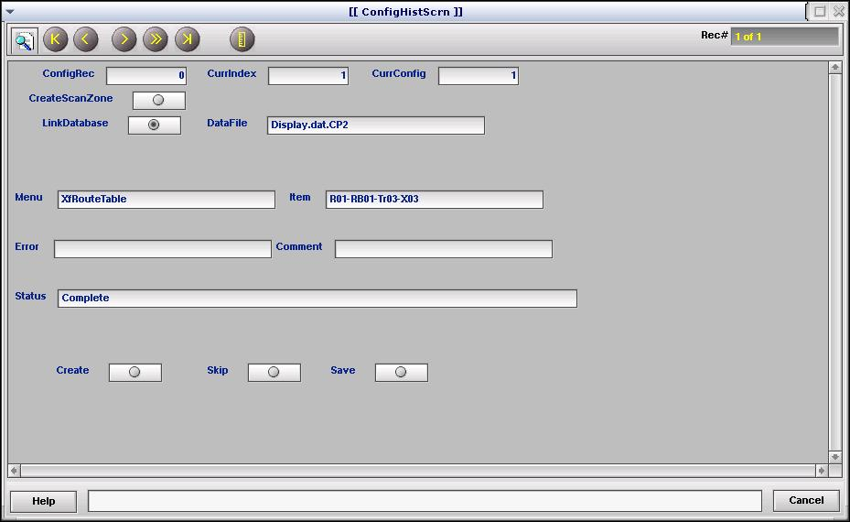
The block of six fields in the top portion of the screen are set automatically and should not be altered.
Pay particular attention to the block of five text fields in the center portion of the screen. The current table and item in question, or other information appear in the first two fields of this section. The others may show messages regarding the current state of the wizard.
You will interact with the screen and control the items included in the configuration using the three buttons in the lower portion of the screen.
Upon opening the history configuration wizard, it will offer to “Clear old Hist Config” in the Menu field, and prompt you with “Select Create” in the Status field. Click the Create button to get started. You will see it is quite easy to run through the wizard again, if needed, so don’t worry about losing the current configuration!
Each configurable item is presented, one by one. Inspect the Menu and Item fields to decide whether you wish to include the item (Create) or ignore the item (Skip). The items are presented in this order: ScnScanZone, ScnScanDevice, Inpoints, Divert Points (Outpoints), XfRouteTable. If nothing has been configured for a given type of item, it will not be presented.
When the last item has been presented, the Status field will display “Complete”. Click Save to record the changes and create the necessary configuration file for the Display program. The Status field will show summary results. The resulting Display.dat.<ACNAME> file is also automatically distributed to all visible AC nodes.
Click Cancel when finished, or close the window using the X. If you wish to re- run the wizard, close it and re-open it to start again.

  - Check the HistConfig Table
Open the HistConfig table (Configuration Menu | History Utilities | History Config Menu). Inspect the UpdTime column. Any that are not updating or have a value of 0 may require an entry in the IOSignal column. This often occurs for Run Time (RnTm) and Stops (Stps) items. Choose a signal (often the motor for the item in question) that will reveal when the item is active.

Launching the Display Program
Start the Scanner Statistics Display program from Operator Menu | Scanner Statistics. The Scanner Stats Panel displays a list of ACs. The list is constructed based on entries in the Machine table. In a properly configured system, all ACs should have statistics configured – or at least all ACs that control anything that has statistics to report. You may remove items that you do not wish to see by clicking the Remove from List button. You can restore the list or rebuild it if new AC configurations are added by clicking the Refresh button in the lower-left corner.
Click the Scanner Statistics button for the AC of interest to open Display with the configuration for that AC.
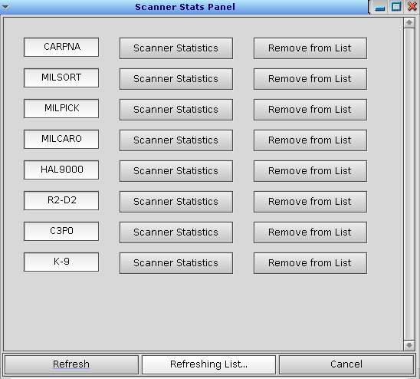
When the Scanner Statistics button is clicked for the first time for an AC, the Display.config.<ACNAME> file will be created automatically. See section 14 for details on the configuration files and modifications that can be made within them once they have been created.

The Display Program
The Display program, commonly referred to as “Scanner Stats” is a separate program that uses the data collected by the history module to show performance information for the previous (rolling 7-day) week. It retrieves the data from the MySQL database tables DbHistConfig and DbHistData. It also requires the Display.config.<ACNAME> and Display.dat.<ACNAME> files.
Tabs in the program display data for Rates, Lanes, Sorters, and Scanners. One day’s data is displayed at a time. The day defaults to today, but any weekday can be selected.
  - Rates Data Tab
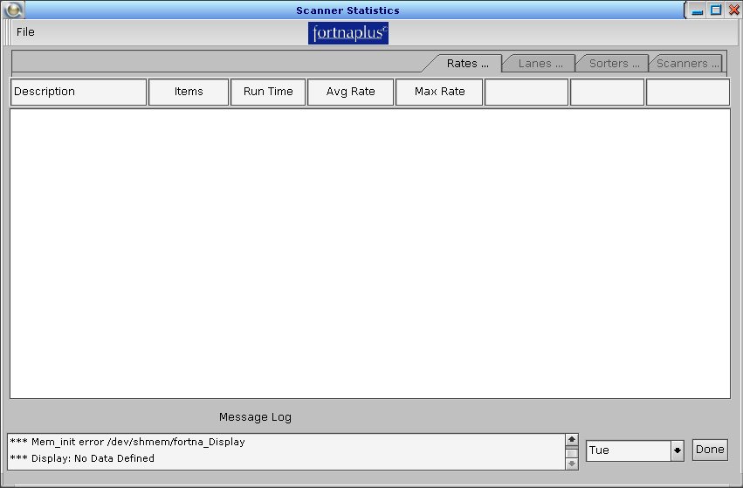
- Items – The number of containers detected at the sorter induct.
- Run Time – The total time the sorter was running, in minutes.
- Avg Rate – The average rate, calculated as Items divided by Run Time, in containers per minute.
- Max Rate – The maximum rate observed on the sorter for any one-minute period, in containers per minute.

  - Lanes Data Tab
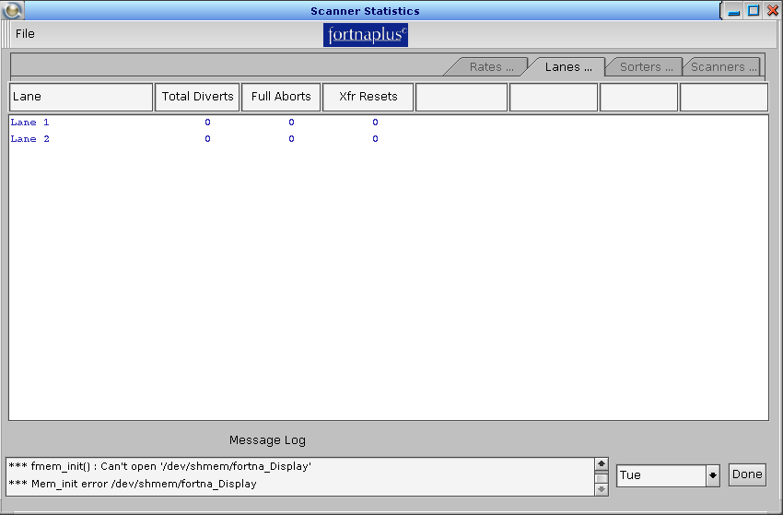
- Lane – The lane name from the configuration files.
- Total Diverts – The total number of diverts for the lane.
- Full Aborts – The total number of diverts that were not successful because the lane was full.
- Xfr Resets – For transfer configurations, the total number of transfer reset events.

  - Sorters Data Tab
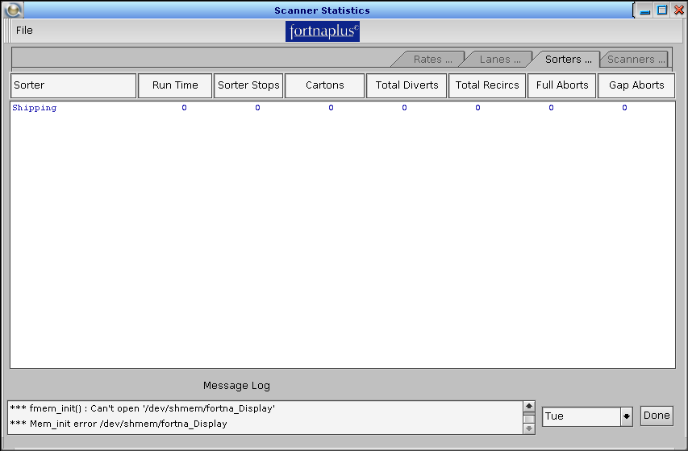
- Sorter – The sorter name from the configuration files.
- Run Time – The total time the sorter run signal was ON, in minutes.
- Sorter Stops – A count of times the sorter run signal went OFF.
- Cartons – The number of containers detected at the sorter induct point.
- Total Diverts – The sum of the individual lane diverts from the Lanes tab.
- Total Recircs – The total number of recirculated containers as detected by the photoeye at the end of the sorter.
- Full Aborts – The total number of unsuccessful divert attempts due to full lanes, summed from the individual lane data on the Lanes tab.
- Gap Aborts – The total number of un-attempted diverts due to bad gaps detected on the sorter.

  - Scanners Data Tab
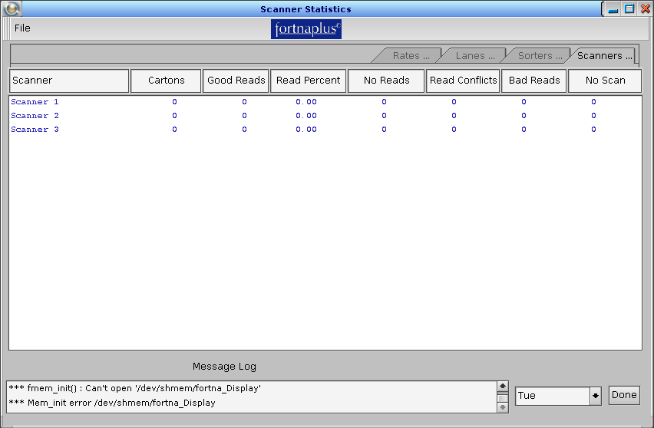
- Scanner – The scanner name from the configuration files.
- Cartons – The number of containers detected at the induct point for the shifter associated with this scanner.
- Good Reads – The number of good read events for this scanner.
- Read Percent – Good reads as a fraction of total detected containers, expressed as a percentage. Total detected containers is calculated as the sum of Good Reads, No Reads, Read Conflicts, Bad Reads and No Scans.
- No Reads – The scanner sends a special string to indicate it could not read the barcode on a container it detected. This is the sum of those events.
- Read Conflicts – The scanner sends a special string to indicate it read more than one barcode and they were not the same. This is the sum of those events.
- Bad Reads – The scan reported did not meet optional criteria defined in FPC for expected string length. This is the sum of those events.
- No Scan – FPC records this error when a container passes the scan point completely and the scanner does not respond. This is the sum of those events.

  - Display Program: Edit Configuration
Though it is not generally needed, the configuration used by the Display program can be viewed and edited within the Display program. Click File | Edit Configuration to open the window:
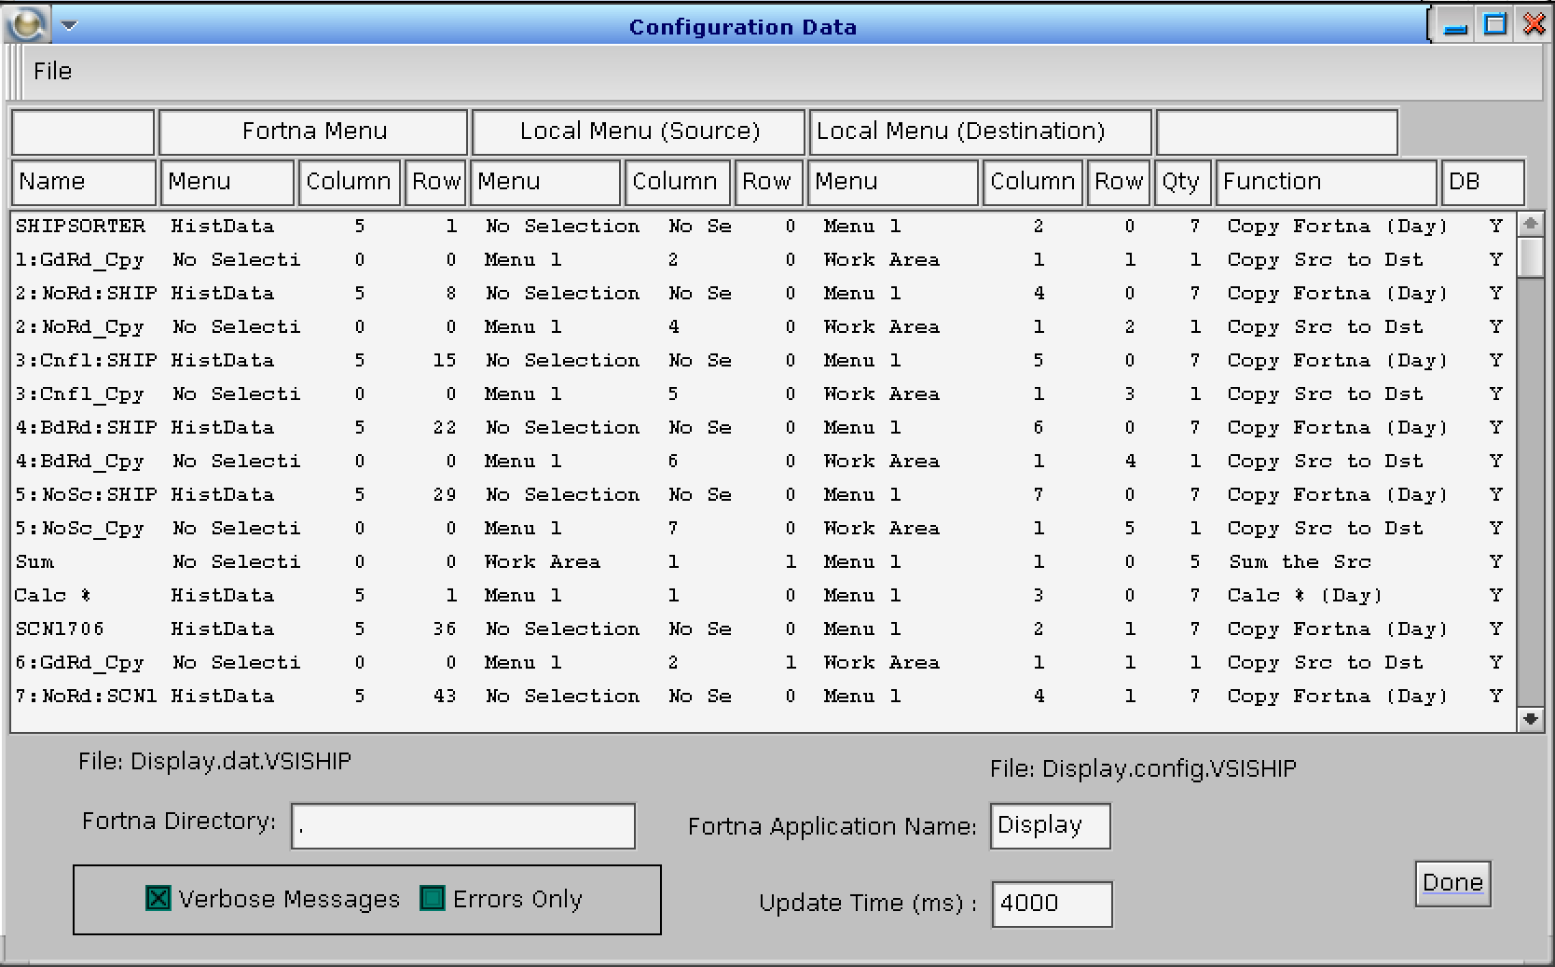
The current Display.dat and Display.config file names are shown in the lower pane. The Fortna Directory entry of “.” (dot) indicates the files were read from the “current directory”. When Display is started in the normal way from within FPC, that would be /SortPlus/RUN.
You can see names, tables, columns, and rows that should look familiar from the results of the configuration wizard, as defined elsewhere in this document. The Function column comes from the Display.dat file and tells Display how to process and display the information. See the next section. The DB column indicates that the data source is the MySQL database.
If you click on an item, the Configuration Data Entry screen will appear. You could use this to alter the configuration.
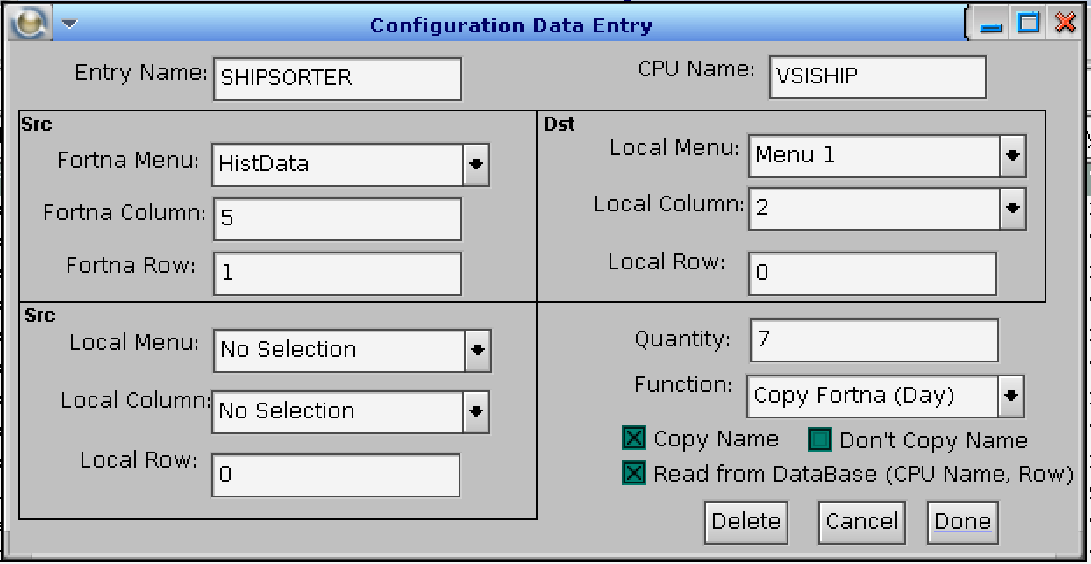
The first Src section defines the source of the data. The second Src section defines local tables for additional data needed by some of the functions. The Dst section defines the destination tab within the Display program window where the data is to be displayed. The section in the lower right defines the function to use and how to process it.
When the Read from Database box is checked (It always is!) and the function is Copy Fortna (Day), the CPU Name must be entered, and Quantity must be 7!
Any variable that is read from the database must also have a Src Fortna Row value assigned.
If the Read from Database box is checked and the function is Copy Fortna to Dst, the AccumTotal from DbHistConfig is read. The CPU Name must be set, and Entry Name must be set to the DbHistConfig record name.

    - Functions
This section describes all the available functions.
Copy Fortna to Dst – Copy data from shared memory to the table defined in Dst Local Menu on the right-hand portion of the screen. If the Dst Local Row is non-zero the Src Fortna variable will be divided by the value of the row.
Copy Src to Dst – Copy data from the table defined in Src Local Menu in the lower-left-hand portion of the screen to the Dst Local Menu defined on the right-hand portion of the screen.
Sum the Src – Sum the items from the table defined in Src Local Menu and store the result in the Dst Local Menu.
Calc % – Calculate the percent of the Src Fortna Menu divided by the Src Local Menu and store the result in the Dst Local Menu.
Copy Fortna (Day) – Copy data from the Src Fortna Menu based on the current day of the week. The Quantity must be set to 7 even though only one value is stored in the destination. The function will determine the current day of the week and copy the data into the Dst Local Menu. If the “Src Local Row” is non-zero, the Src Fortna Menu variable will be divided by the value of the row.
- Copy Name to Dst – Copy the Name field to the destination, as follows:
  - Copy the Name field to the Dst Local Menu first column if the Src Local Menu has been selected and Src Local Column is set to “No selection” and Src Local Row is set to 0.
  - The function will copy the text from the Name field to the column header if a column other than “No selection” is selected and Dst Local Menu has been selected.
  - The function will copy the text from the Name field to the Selection tab if the row is set to –1 and a Dst Local Menu has been selected. In addition, if the Quantity is greater than zero the function will set the number of columns displayed to the Quantity value.
  - The function will change the display format of the column from zero digits to the right of the decimal point to one digit to the right of the decimal point if the row is set to –2 and a table and column has been selected in the destination.
  - The function will change the display format of the column from zero digits to the right of the decimal point to two digits to the right of the decimal point if the row is set to –3 and a table and column has been selected in the destination.

Calc % (Day) – Calculate the percent of the daily data from Src Fortna Menu divided by the data from Src Local Menu. The result will be stored in the Dst Local Menu. The Quantity must be set to 7 even though only one value is stored in the destination. To calculate the percentage using the Src Local Menu data divided by the Src Fortna Menu data (the inverse), set the Quantity to -7.
Division (Day) –
Diff (Day) –

  - Display Program Command Line Options
Command-line options can be used to alter how the Display program starts. These are not usually needed for the way we use the program, as all of this is pre-defined in the calls from FPC.
-s server Set the server node or device
-x x Set the initial X position of the window on the screen
-y y Set the initial Y position of the window on the screen
-h h Set the initial window height
-w w Set the initial window width
-S [i m n] Set the initial window state:
i = Iconified
m = maximized
n = normal
-f filename Load a file that defines the configuration
-n Don’t save configuration changes made while running

  - Display Program: File Menu
We have already described the Edit Configuration option in detail, above, but the File menu within the Display program has a number of other options. Here is a brief description:
Edit Configuration – Edit the configuration that defines the input data and how it is to be displayed. See section 6.5 for details.
Save Parameters – Select a file and save the current configuration parameters to it.
Save Display – Select a file and save the variable list for the current configuration.
Open Parameter File – Select a parameter file (previously saved with Save Parameters) to load.
Open Display – Select a Display file (previously saved with Save Display) to load.
Clear Accum Values – This item will clear the accumulated values stored in the HistConfig or DbHistConfig tables. Clearing the value from DbHistConfig will not clear the value in HistConfig. This is of little use the way we have come to use Display, as HistConfig_AccumTotal is not shown anywhere.

Table HistBoss
Table HistBoss is used to manage how the updates to the MySQL database tables DbHistConfig and DbHistData are performed. All configuration must be done in row 1. The DbQtyConfig and DbQtyData fields set the number of records from each table that are processed in one pass of the “Hist DbCapture Config” and “Hist DbCapture Data” batch jobs, respectively. UpdAllDays controls how many days of the week are updated on each pass. For the normal setting of 0, today’s and yesterday’s data are updated. If you set UpdAllDays = 1, all seven day’s data is sent to MySQL on each pass.
HistBoss Table
Field | Type | Description
Name | String | A name for the entry. Only row 1 is used.
DbQtyConfig | Int | Set the number of HistConfig records to be sent to DbHistConfig on each pass. The default is 1.
DbQtyData | Int | Set the number of HistData records to be sent to DbHistData on each pass. The default is 1.
DbCurrConfig | Int | Set by the software to the current record in table HistConfig.
DbCurrData | Int | Set by the software to the current record in table HistData.
DbUpdateData | Int | An internal flag.
DbAddData | Int | An internal flag.
DbUpdateConfig | Int | An internal flag.
DbAddConfig | Int | An internal flag.
UpdAllDays | Int | Controls how many days of the week are updated on each pass.  0 = Update today’s and yesterday’s data.  1 = Update data for all days of the week.  Use this to force database updates quickly after a configuration change.

Table HistConfig
The HistConfig table (Configuration Menu | History Utilities | History Config Menu) is used to define how data is collected.
HistConfig Table
Field | Type | Description
Name | String | A unique name created by the history configuration wizard. This field is split into Name1 and Name2 in the DbHistConfig table, with the first 10 characters in Name1 and the rest in Name2 – for historical reasons. It is composed of the AC name, the row number in this table, a four-character code for the type of data (example: NoRd), and the name of the device that generates the data. The elements are separated by colons. Also used by the HistSearch command.
UpdTIme | Int | A Unix timestamp value updated by the software each time the item is refreshed.
Type | PopUp | Defines the type of processing for the signal. Set by the wizard. The choices are:  Count Rising Edge  Count Falling Edge  Time When On  Time When Off  Min Rate per Min  Max Rate per Min
NumDays | PopUp | Defines how many days’ worth of data to store. Set by the wizard. The choices are:  One Day  One Week  One Month  One Year  The wizard always chooses One Week. The Display program expects One Week, so the other choices are not really viable – TRK.
LastState | Int | Set by the software. Represents the last state of IOSignal.
IOSignal | PopUp | Some items, like Run Time and Stops, require a signal to be chosen manually so the software can know when the item changes state. Choose an IO part (usually a motor) from the Conveyor table. Look for items that do not show a changing value in the UpdTime field to know if an entry is needed here.
LastDay | Int | Set by the software. Represents the last record updated in table HistData.
LogFlag | Y/N | Controls whether the data for this item will be written to the log file defined in LogFile.
LogFile | PopUp | Choose an optional log file. If this is defined, and LogFlag is set, the data will be written to the log file.
HRStart | Int | Set by the software to the column number (counting from zero) of the HR00 column in table HistData.
HREnd | Int | Set by the software to the column number (counting from zero) of the HR23 column in table HistData.
DbCaptureFlag | Y/N | Set by the wizard to indicate this item should be copied to the DbHistConfig table. Always Y
AccumTotal | Int | Set by the software. The running total for this item. Must be reset manually.
AccumMinute | Int | Used internally to track when the current data accumulation period expires, and a new period begins.
MinMinute | Int | Used internally to track when the current data accumulation period expires, and a new period begins.
MaxMinute | Int | Used internally to track when the current data accumulation period expires, and a new period begins.

Table HistData
The HistData table contains the collected and partially summarized data for specific collection periods. Each record is linked to the row in HistConfig that defines it.
HistData Table
Field | Type | Description
Name | String | A unique name created by the history configuration wizard. It is composed of the AC name, the day number and weekday name. This field is split into Name1 and Name2 in the DbHistData table, with the first 10 characters in Name1 and the rest in Name2 – for historical reasons.
UpdTime | Int | A Unix timestamp value updated by the software each time the item is refreshed.
ConfigRecord | PopUp | Set by the software. A reference to the row number in the HistConfig table.
DbUpdReq | Int | Set by the software when a change has been detected to indicate that the updated record should be pushed to the database tables.  Also set by the “Hist Set DbUpdReq” and “Hist Clear Data” functions when run manually.
Day | Int | The day number associated with this data. Sunday is zero.
DayTotal | Int | The sum of all hourly data in columns HR00 through HR23 for this record.
LogReq | Int | Set by the software to indicate the data from this record needs to be written to the log file. See HistConfig_LogFlag and HistConfig_LogFile.
HR00 – HR23 | Int | The hourly data is collected in these 24 columns.
EventDate | String | The calendar date, as a string in YYYY-MM-DD format, when the first event in the period occurred. See the column of the same name in table DbHistData.

Table DbHistConfig
Data from memory-based table HistConfig is copied to database table DbHistConfig by the “Hist DbCapture Config” Batch job. There are a few important differences.
DbHistConfig Table
Field | Type | Description
Name1 | String | The first 10 characters from HistConfig_Name.
Name2 | String | The rest of the characters from HistConfig_Name.  QNX4 Sybase could not generate an index on more than 10 characters of a string field, so Name was split into two parts, Name1 and Name2 – each 10 characters long and both indexed. With the automatic naming convention used by the history configuration wizard, the full 20 characters is often required for uniqueness. This was carried over to QNX6 and MySQL, though MySQL does not have the restriction on the indexing.  In all versions up to V11.40.0, Name2 is limited to 10 characters, as well. The Display program reads the entire name from the configuration files for display, so that is not an issue, but it still requires uniqueness in the first 20 characters of HistConfig_Name. This causes a problem if you try to extract the information directly from the database tables, as important information may be missing.  As of V11.41.0, the Name2 field is expanded to 30 characters, giving a total of 40 characters for the complete name. The latest version of the Display program is compatible with this. It is backward-compatible with the older database configuration, but still requires uniqueness within the first 20 characters. Direct database queries can take advantage of the complete name.
UpdTime | Int | The Unix timestamp value from HistConfig_UpdTime..
Type | PopUp | The processing type taken from HistConfig_Type. An integer value is recorded here, representing the index into the HistType table.  The choices are:  1 – Count Rising Edge  2 – Count Falling Edge  3 – Time When On  4 – Time When Off  5 – Min Rate per Min  6 – Max Rate per Min
NumDays | PopUp | The data retention time taken from HistConfig_NumDays. An integer value is recorded here, representing the index into the HistNumDays table.  The choices are:  1 – One Day  2 – One Week  3 – One Month  4 – One Year  The wizard always chooses One Week, so this value will always be 2 in this table.
LastState | Int | Taken from HistConfig_LastState.
IOSignal | PopUp | Taken from HistConfig_IOSignal. An integer value is recorded here, representing the index into the Conveyor table for the IO part selected. Usually 0 for the INVALID part.
LastDay | Int | Taken from HistConfig_LastDay.
LogFlag | Y/N | Taken from HistConfig_LogFlag. 0 = N, 1 = Y.
LogFile | PopUp | A reference to the log file defined in HistConfig_LogFile. An integer value is recorded here, representing the index into the LogFiles table.
HRStart | Int | Taken from HistConfig_HRStart.
HREnd | Int | Taken from HistConfig_HREnd.
DbCaptureFlag | Y/N | Taken from HistConfig_DbCaptureFlag. Always 1 = Y.
AccumTotal | Int | Taken from HistConfig_AccumTotal. The running total for this item. Must be reset manually.
RecNum | Int | The row number in HistConfig. Use this to join with table DbHistData_ConfigRecord.
LastFetched | DateTime | The date and time when this record was last refreshed from table HistConfig.
CPUName | String | The name of the AC that owns this record.

Table DbHistData
Data from memory-based table HistData is copied to database table DbHistData by the “Hist DbCapture Data” Batch job. There are a few important differences.
DbHistData Table
Field | Type | Description
Name1 | String | The first 10 characters from HistData_Name.
Name2 | String | The rest of the characters from HistConfig_Name.  The same comments apply here as for DbHistConfig_Name2.
UpdTIme | Int | The Unix timestamp value from HistData_UpdTime..
ConfigRecord | PopUp | An integer that refers to DbHistConfig_RecNum. Use this to join the two tables for SQL queries.
Day | Int | Taken from HistData_Day. An integer value representing the day of the week. Sunday = 0.
DayTotal | Int | Taken from HistData_DayTotal. This is the value that will likely be most useful. It is the value used in the Display program for most things.
LogReq | Int | Taken from HistData_LogReq.
HR00 – HR23 | Int | The hourly total values taken from the similarly named fields in table HistData.
EventDate | String | The calendar date, as a string in YYYY-MM-DD format, when the first event in the period occurred. This is used by the Stats Archive feature when copying data to table HistSummary. It creates an absolute time reference for the record, instead of the day of week relative reference. This makes it easier to collect the data for long-term archival purposes. See section 13.
LastFetched | DateTime | The date and time when this record was last refreshed from table HistData.
CPUName | String | The name of the AC that owns this record.
To extract data directly from MySQL, use a query like the example, below. The example shows the basic join between the two tables, and how to reconstruct the original Name fields from the in-memory tables. You can build upon this example by restricting to a particular Day, or CPUName – let your imagination run wild
select concat(c.name1, c.name2) as CName, concat(d.name1, d.name2) as DName, c.accumtotal, d.day, d.daytotal, d.cpuname from dbhistconfig c, dbhistdata d where c.recnum = d.configrecord;

Data Collection Details
Within the FPC software, several functions are used to gather the data. They can count transitions, accumulate elapsed time, or update the state of a signal.
These functions are called within the FPC code:
hist_updhour(int menu_row, time_t timestamp, int upd_value, int chk_max_time). The sorter module calls this function to record the number of containers inducted each hour, for example.
hist_upd_record(int menu_row, time_t timestamp, int upd_value, int iostate). The sorter module calls this function to record to count transitions associated with diverts, for example.
read_hist_item(int row, int *num_of_items, time_t start_time)
hist_search(chr *string)
NOTE: For items involving time, the minimum measurable time for the history module is 1 second.
These functions can be called from table Batches, from triggers, or run manually:
hist_process() – Processes the signals with the IO defined. Called “Hist Process” in InternalProc or InternalProcCtrl.
hist_logging() – Logs the day records whenever the log flag is set. The log flag is set by the hist_process() function (or one of the application functions) whenever it detects a transition in the day. This function may be set to run at long intervals. Called “Hist Logging” in InternalProc or InternalProcCtrl.
HistDBCaptureConfig() - Copies any HistConfig memory-based table records to the MySQL database table DBHistConfig. Only records that have the DBCaptureFlag set to Y are copied. Since the configuration records rarely change, the Batch job is usually run once per minute. Table HistBoss, column DbQtyConfig controls how many rows are updated on each pass. The default is one. Called “Hist DbCapture Config” in InternalProc.
hist_search() – At startup, this function determines the current record in table HistConfig.
HistSetDbUpdReq() – Called “Hist Set DbUpdReq” in the procnames (or Security) table (Administration Menu | Set Security Levels). This function can be called from the Security table using Alt-K. It sets the DbUpdReq flag on all active rows. This causes all rows in table HistData to be scheduled to update the rows in DbHistData. This is helpful for debugging or to force updates, as viewed in the Scanner Stats Display program, to re-synchronize as quickly as possible after a configuration change.
HistClearAll() – Called “Hist Clear Data” in the procnames (or Security) table (Administration Menu | Set Security Levels). This function can be called from the security table using Alt-K. It sets all hourly and DayTotal data to zero in table HistData. This is helpful to eliminate invalid data after configuration changes.
hist_test() – Called “Hist Test” in InternalProc and InternalProcCtrl. This function can be called from the Security table using Alt-K. It finds the first “No Read” record and adds 5 to its count. It finds a “Test Upd_Record” and simulates an ON/OFF event. It toggles HistConfig_IOSignal for the first record. It reports to the GUI log with information about the configured items it finds (search the log for items tagged with “hist_test”).
hist_reconfig() – Called “Hist Reconfig” in InternalProc and InternalProcCtrl. This function can be called from the Security table using Alt-K. It clears tables HistConfig and HistData, then calls hist_config() to repopulate from the configuration items created by the wizard (which are stored in various other tables). This would only be needed to clear data from the in-memory tables and is not required for normal operation. You will see a message in the GUI log, tagged with “hist_reconfig”. The message will let you know if table HistData is not large enough.

NOTE: If an item is processed in one of these function calls, HistConfig_IOSignal must not be selected. This is normally handled by the configuration wizard.

The Stats Archive Feature
A semi-frequent request from our customers is to retain the Scanner Statistics data for longer than one week.
A special shell script, StatsArchive, along with an additional MySQL database table, DbHistSummary, can be used to do just that.
The script is run as a cron job, external to FPC. It extracts data from the DbHistConfig and DbHistData tables, summarizes it and reshapes it for storage in table DbHistSummary. It also does housekeeping on DbHistSummary – and on DbHistConfig and DbHistData to ensure that stale data is purged if configuration changes are made. StatsArchive resides in /usr/local/bin (once installed). Run it with the -h option to see a help message. The default retention time is 60 days, which can be altered by editing the script. Look for SUMMARYRETAINDAYS. You will also need to adjust the database connection information to match the MySQL instance.
A set of four companion scripts, also intended for use via cron, make it easy to extract a daily summary, suitable for loading into a spreadsheet, that mimics the four tabs found in the Scanner Stats Display program: SALanes.sh, SARates.sh, SAScanners.sh, and SASorters.sh. These also have database connection information that will need to be adjusted.
The DbHistSummary table is defined by the StatsArchive script – not within FPC, but will peacefully co-exist.
DbHistSummary Table
Field | Type | Description
EventDate | Date | Taken from DbHistData_EventDate, if available. Prior to V11.48.0, the date is inferred by the StatArchive script using the HistData_Day value and the current database timestamp (now()). This is meant to be the calendar date for the data. In addition to using it for display of the data, it is also used to know when to housekeep the data.
CPUName | String | Taken from DbHistData_CPUName.
Entity | String | Derived from the device name taken from the last part of HistConfig_Name. A scanner, or sorter lane, or transfer, for example.
GdRd | Int | The number of Good Reads.
NoRd | Int | The number of No Reads.
CnFl | Int | The number of Read Conflicts.
BdRd | Int | The number of Bad Reads.
NoSc | Int | The number of No Scans.
NoDt | Int | The number of No Data events.
RnTm | Int | The Run Time, in minutes.
Stps | Int | The number of sorter Stop events.
Itms | Int | The number of Items.
FlAb | Int | The number of Full Abort events.
GpAb | Int | The number of Gap Abort events.
Dvrt | Int | The total number of Diverts.
XRst | Int | The number of Transfer Resets.
Max | Int | The Maximum rate.
Page | Int | A binary coded value for the pages in the Display program that this Entity appears on.  1 – Page 1  2 – Page 2  4 – Page 3  8 – Page 4  Some Entities appear on more than one page, so the get a value that is the sum of those pages:  6 – Pages 2 and 3  10 – Pages 2 and 4
ReCr | Int | Not used. (Should be removed – TRK)

The Old Way
In FPC versions prior to V10.89.0, many configuration tasks that are now automated needed to be done manually. There is still some value in understanding the way in which all the parts of the configuration interact to allow you to open the Display program from within FPC.
Now, the Scanner Stats Panel is automatically generated from the configuration files when Operator Menu |Scanner Statistics is opened. Previously, Operator Menu | Statistics Utilities was used for this purpose. It is hidden now by default on the Operator Menu. To use it, you had to modify the fortna.mnu file to add entries for each AC in the definition of the StatisticsUtil menu. Data_Type = 41 indicates that the menu item should try to run the Batches table entry called out in column DataString. You would copy the Display CP1 line, for example, and modify its name and the Display1 entry near the end of the line to reflect the new AC. This had to be done by editing the file outside of FPC while FPC was not running. Here is the StatisticsUtil menu definition from the fortna.mnu file:
'StatisticsUtil' 0 0 18 8 15 18 0 0 0 0 0 65 1 26 5 1 0 0 0 0 0 0000000000000000
'Display CP1' 41 30 0 0 ' ' 256 0 0 61 0 0 0 18 26 9 10 0 30 3 'Display1' 0 0
'Display CP2' 41 30 0 0 ' ' 256 1 0 61 1 0 -1 18 26 9 10 0 30 3 'Display2' 0 0
'Display Logs' 41 30 0 0 ' ' 256 0 0 61 25 0 1 18 26 9 10 0 30 3 'Logs' 0 0
Using “Display CP1” as an example, it calls Batches entry Display1, which is a shell script in /SortPlus/RUN that contains this:
#!/bin/sh
#
#
#
if ps -ef | grep -v grep | grep Display
then
echo Display Running, slaying
slay -f Display
nice /usr/local/bin/Display -f Display.config.CP1
else
nice /usr/local/bin/Display -f Display.config.CP1
fi
This shell script starts the Display program using the Display.config.CP1 configuration file. To create a script for a new AC required copying this file and editing the copy to replace CP1 (in two places) with the new AC name. As before, this file must be distributed to the other ACs. Newer versions automatically generate script Display<ACNAME> as needed and with the correct content.
Similarly, the Display.config.<ACNAME> file had to be created to match the name referenced in the shell script. It, in turn, refers to the Display.dat.<ACNAME> file from the history configuration wizard. Here are the contents:
mlg:0
fpd:. (Note the ‘dot’ at the end of this line)
fpa:Display
cfg:Display.dat.CP1
tmb:4000
dbi:0
The value on the “tmb” line specifies the refresh rate in the Display program, in milliseconds. This file must also be distributed to the other ACs. Newer versions automatically generate the config file in the correct form when needed. Once generated, though, you can edit that tmb value and it will be retained.
The Display.dat.<ACNAME> file generated by the history configuration wizard had to be distributed to all ACs manually. It resides in the /SortPlus/RUN directory. In a command-line window:
cd /SortPlus/RUN
distribute Display.dat.<ACNAME>
where <ACNAME> is the name for THIS AC. This is needed so the statistics for THIS AC can be viewed from the other ACs.
All these manual steps are now automated!
The details of how these files interact are still true, however, so the information is still useful for troubleshooting. The Display.dat.<ACNAME> file contains the definition of the items to display and the method for displaying them. It is read by the Display program. This information is NOT kept in the database tables. The data values displayed ARE kept in the database tables. This can sometimes lead to trouble when the database data is misinterpreted by the Display program, leading to incorrect data being displayed. Re-running the history configuration wizard can also create a situation where old data items get ‘abandoned’ in the database tables, so they no longer get updated. They also do not get deleted, leading to incorrect data being displayed. When changes are made to the configuration, it is best to clear the database tables, or at least all the data older than one week.

The Trend Module
In QNX4, a separate program called Trend was available to plot the data collected through the history module. It was never ported to QNX6.
This section preserves the information on how to use it, for posterity.
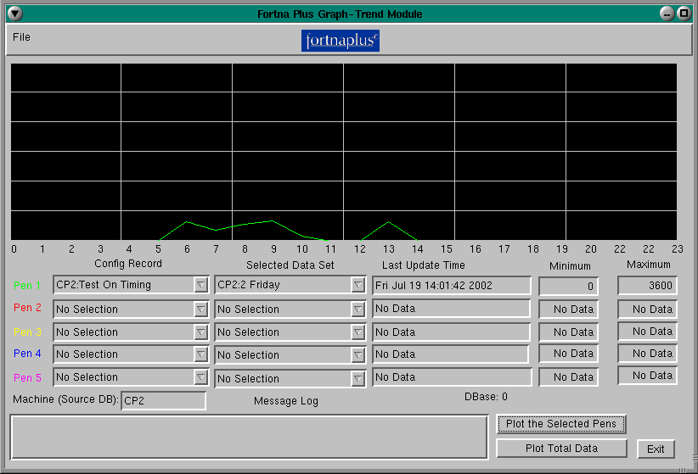
The Graph or Trend Module can display history data or show trends in real-time data. It is an external program that can be run separately from FPC or it may be started from an FPC menu selection. The module reads data from either an ASCII file (created by the FPC print utility (.dat files)), from the FPC Log function (.log files)), from the FPC Sybase database, or it can read data directly from the shared memory section of FPC.
The Graph-Trend module can be configured with up to five “pens”. Each pen can be assigned to a HistConfig record. The Last Update Time, Minimum and Maximum values are displayed for the selected data sets.
The lower-right corner of the window has two buttons for selecting either data associated with a specific day (Plot the Selected Pens), or data for a group of days (Plot Total Data).
For example, to view the run time for Monday, Tuesday, Wednesday, Thursday, and Friday for the system, select the “System Run Time” as the “Config Record” for each of the five pens. Select the days Monday through Friday for each of the five “Selected Data Sets” and click the “Plot the Selected Pens” button.
As another example, to view the performance of the sorter for the week, select “Sorter Uptime” in the “Config Record” for Pen1, and “Total Items into Sorter” in the “Config Record” for Pen2. Click the “Plot Total Data” button. The trend will add up the data for each day and display the seven days of data for each item selected.

  - Trend Config and Calculation Screen
The Configuration and Calculation screen provides the ability to create calculated data sets for plotting and configuration parameters for the graphing module.
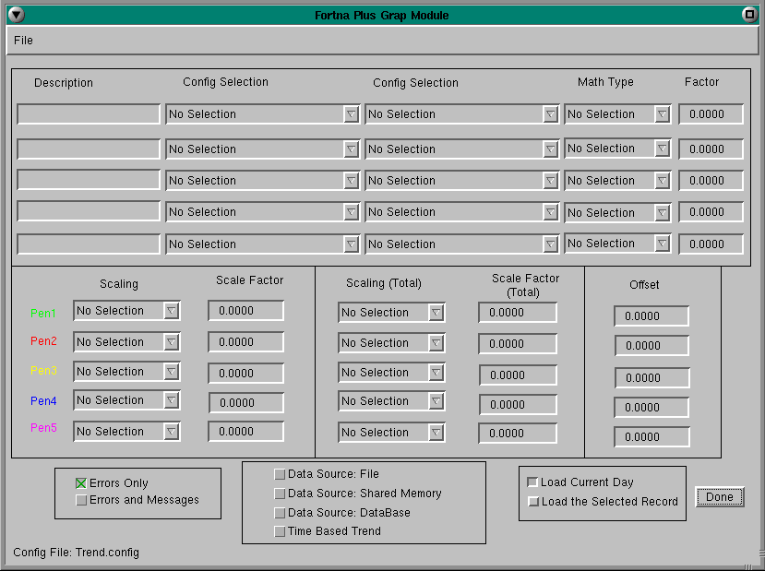
In the calculation screen, up to five calculated data sets may be selected. For each data set, a configuration record may be selected along with the math type and factor.
For example, to calculate the percent of “No Reads” select the “No Read” dataset and the “Total Items into Scanner” data sets. Select the “Divide” Math type and a factor of “100”. The module will create a new data set called “Calc Test1” with the percentage of no reads.
The bottom section of the window provides configuration tools to define the scaling factors for each pen. The first set of scaling methods and scaling factors are applied to daily data sets. The second set of scaling methods and scaling factors (the Total fields) are used when total data sets are plotted. The Offset is applied to either the Daily or the Total trends.
Each trend line may be manually scaled, and an offset applied to position the trends for easy viewing. If the scale factor is set to “No Selection” or manual scale mode, the data will be scaled using the factor and offset entered. The acceptable range for the scale factor is 0 to 32766.
NOTE: When auto scaling is turned off the minimum and maximum value of the graph is 0 and 32,766.
The set of buttons at the lower left of the screen provide the ability to log “Errors Only” or “Errors and Messages” (diagnostic messages are provided as a debugging tool). Messages are logged to the scrolling window on the main screen.
The set of buttons in the middle box at the bottom of the screen control the data sources: “Data Source: File”, “Data Source: Shared Memory”, “Data Source: Database”, or “Time Based Trend”. If “Data Source: File” is selected, a file must be chosen using the “Open Data File” pull-down menu options. If “Data Source: Shared Memory” is selected, the application directory and project name must be entered in the “Configure Memory” window. If “Data Source: Database” is selected, the module will look in the Sybase database for the DBHistConfig and DBHistData tables and will use the “Machine (Source DB)” field displayed on the main screen to filter the table data by CPU or machine name (in addition, the trend config file contains a database index if multiple databases are used for the application). If “Time Based Trend” is selected, the application directory, project name, time interval, pixel interval, menu, column, and row fields must be defined in the “Configure Memory” window.
The set of buttons in the box at the lower right of the screen determine the dataset that will be used. The “Load the Current Day” option will attempt to load the current-day data set if plot mode is not set to plot totals. The “Load the Selected Record” option will display the data associated with the selected trend data set.
NOTE: The trend program looks for one week of data. If it does not find a full week, it does not select the current day. If the trend module is configured to load from the database, seven days of data will not be available in the database tables until a full week has passed, or you set HistBoss_UpdAllDays = 1 (Allow a few minutes for the updates to occur).

  - Trend Shared Memory Configuration Screen
The shared memory configuration screen lets you define up to five variables for time-based plotting. The Application Directory and Project Name must be entered to link to FPC before other selections can be made.
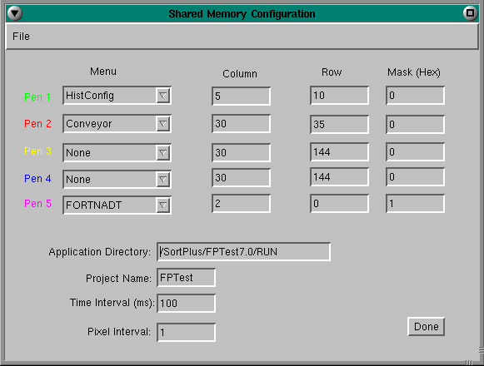
Use Menu to select the FPC table to use as the data source. Up to five can be chosen.
Use Column and Row to choose the data within each table.
Use the Mask column to select a specific bit, if needed. The value is in hexadecimal. For example, to select only the fifth bit, enter 10. A value of 0 applies no mask.
To find the Project Name, run the command: ls /dev/shmem. Remove the “Fortna_” prefix from the output to get the Project Name to use here.
Time Interval defines the time between updates, in milliseconds, when using the “Time Base Trend” on the Config and Calculations screen.
Pixel Interval defines the spacing between plotted points, in pixels.

  - Graph Trend Program Command Line Options
Command-line options can be used to alter how the Trend program starts.
-s server Set the server node or device
-x x Set the initial X position of the window on the screen
-y y Set the initial Y position of the window on the screen
-h h Set the initial window height
-w w Set the initial window width
-S [i m n] Set the initial window state:
i = Iconified
m = maximized
n = normal
-f filename Load a file that defines the graph configuration
-n Don’t save configuration changes made while running
Trend will read *.dat files or *.log files. The file name extension determines how the graph routine parses the file.
*.dat – HistData type files:
Name, Config Name, Time Stamp, Misc, HR00 – HR23
*.log – Hist Log type files:
Time Stamp + Config Name, Rec Name, HR00 – HR23
*.log – General Log type files:
Time Stamp, Config Name, Data

